Ethiopia

## Political Stability Estimate Data

The data set shows the political stability estimate of the country each year.

## # A tibble: 19 x 5  
## country iso3c date stability stabilityCategory4   
## <chr> <chr> <dbl> <dbl> <chr>   
## 1 Ethiopia ETH 1996 -1.05 highly unstable   
## 2 Ethiopia ETH 1998 -0.630 moderately unstable  
## 3 Ethiopia ETH 2000 -0.944 moderately unstable  
## 4 Ethiopia ETH 2002 -1.22 highly unstable   
## 5 Ethiopia ETH 2003 -1.41 highly unstable   
## 6 Ethiopia ETH 2004 -1.31 highly unstable   
## 7 Ethiopia ETH 2005 -1.69 highly unstable   
## 8 Ethiopia ETH 2006 -1.74 highly unstable   
## 9 Ethiopia ETH 2007 -1.80 highly unstable   
## 10 Ethiopia ETH 2008 -1.73 highly unstable   
## 11 Ethiopia ETH 2009 -1.64 highly unstable   
## 12 Ethiopia ETH 2010 -1.64 highly unstable   
## 13 Ethiopia ETH 2011 -1.51 highly unstable   
## 14 Ethiopia ETH 2012 -1.56 highly unstable   
## 15 Ethiopia ETH 2013 -1.41 highly unstable   
## 16 Ethiopia ETH 2014 -1.34 highly unstable   
## 17 Ethiopia ETH 2015 -1.50 highly unstable   
## 18 Ethiopia ETH 2016 -1.62 highly unstable   
## 19 Ethiopia ETH 2017 -1.69 highly unstable

## Political Stability Estimate Plot

The plot shows the trends of stabilization and destabilization for the each country.

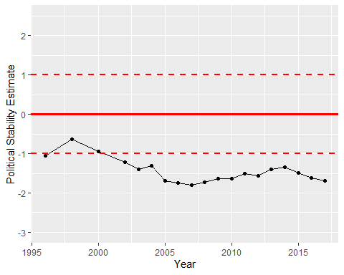

Political Stability Trend